**The Difference Between OPSF Areas**

**By Diego Santos**

**The difference between OSPF Areas**

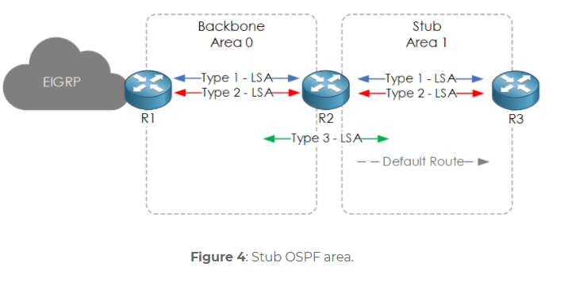OSPF or (Open Shortest Path First) is an algorithm that allows for a more organized and efficient process of sorting routes by using LSA’s or (Link-State Advertisements) to each router, learning their subnets then storing them in a LSDB or (Link State Data Bases). Then by using an algorithm called SPF or (Shortest Path First) and it works for small companies. When you’re a big organization regular OPSF just won’t cut it for you that’s when you employ some other methods of OPSF like Stubby OSPF.

Stubby areas let you control the external routes of an area to one single router like in this picture where there is a default route directed towards the stub area allowing for a less pandemonium when it comes to routes. This figure is a basic example of Stubby area but usually there would be more routers preforming in the OSPF process. But sometime when it comes to extra routes you sometimes have too many routes, so you must go for a totally stubby area.

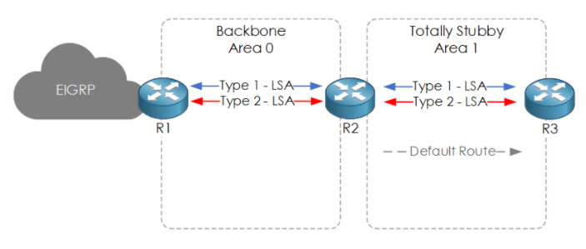A totally stubby area is when in the area you filter both the internal and external routes and replace them with one default route. This is especially helpful when it comes larger companies that receive several different and unique routes. Which leaves only NSSA’s or Not-So-Stubby-Areas.

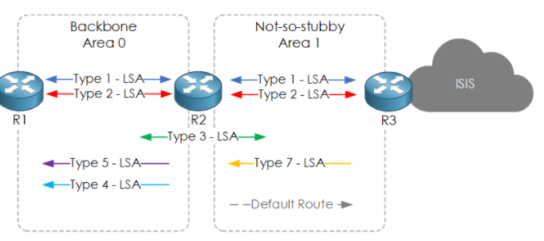Not so stubby areas are like stubby areas but with a special twist use the power of LSA Types it’s able to disguise its packets as LSA type 7 to let it pass through the stub into the backbone then changing into LSA type 5 packets to start into the stub. While were on the topic there are several different LSA types.

Starting with LSA type 1 which is created by each router in each area. LSA type 2 which is created by the designated router then is sent out to the other routers. Then we have LSA type 3 which is sent out whenever routes go to route to route and is called a summary LSA. LSA type 4 is created by the ASBR or Autonomous System Boundary Router that allows all the routes to find the fastest way to external routes. Type 5 LSA is an ASBR Summary route which is self-explanatory. LSA type 7 is only used in NSSA’s when hiding the LSA type 5 until they reach the backbone.

**Works Cited**

<https://www.packetflow.co.uk/ospf-areas-explained/#introduction>

<https://www.youtube.com/watch?v=nayaSlYkQp0>

<https://www.theroutingtable.com/ospf-lsa-types/>

https://www.networkfuntimes.com/ospf-what-is-a-stub-area/